Spectral Unmixing:

Satellite Imagery:
The radiance recorded in satellite images is an integrated sum of the radiances of all targets within the instantaneous field of view (IFOV) of the sensors. Thus, the radiation detected is caused by a mixture of several different materials within the image pixels. In this manner, numerous different materials often contribute to the spectrum recorded in a single pixel of a satellite image.

Need for Unmixing :
Spatial pixel sizes for multispectral and hyperspectral sensors are often large enough that numerous disparate substances can contribute to the spectrum measured from a single pixel. Consequently, the desire to extract from a spectrum the constituent materials in the mixture, as well as the proportions in which they appear, is important to numerous tactical scenarios in which subpixel detail is valuable. With this goal in mind, spectral unmixing algorithms have proliferated in a variety of disciplines that exploit hyperspectral data, often duplicating and renaming previous techniques.

Definition: Spectral unmixing is the procedure by which the measured spectrum of a mixed pixel is decomposed into a collection of constituent spectra, or endmembers, and a set of corresponding
fractions, or abundances, that indicate the proportion of each endmember present in the pixel. Endmembers normally correspond to familiar macroscopic objects in the scene, such as water, soil, metal, or any natural or man-made material.

Mixed Pixels:
Mixed pixels contain a mixture of more than one distinct material substance.

Reason:
- Spatial resolution of an imaging sensor is low enough such that adjacent endmembers can jointly occupy a single pixel, then the resulting spectral measurement will be a composite of the individual endmembers. Occurs due to wide-area surveillance from high altitute
- Distinct materials are combined into a homogeneous mixture (e.g., sand grains on a beach), which can occur regardless of the spatial resolution of the sensor.
A Taxonomy for Unmixing Algorithms:
Objectives:
- distill to a minimum set the universe of algorithms that have arisen from disparate communities by developing a method for hierarchically organizing algorithms by the philosophies they employ for three important characteristics of processing
- roadmap for developers of algorithms

Stages of Unmixing
- dimension reduction- reduce the dimension of the data in the scene. This step is optional and is invoked only by some algorithms to reduce the computational load of subsequent processing
- endmember determination- estimate the set of distinct spectra (endmembers) that constitute the mixed pixels in the scene
- inversion- we generate abundance planes that allow us to estimate the fractional abundances for each mixed
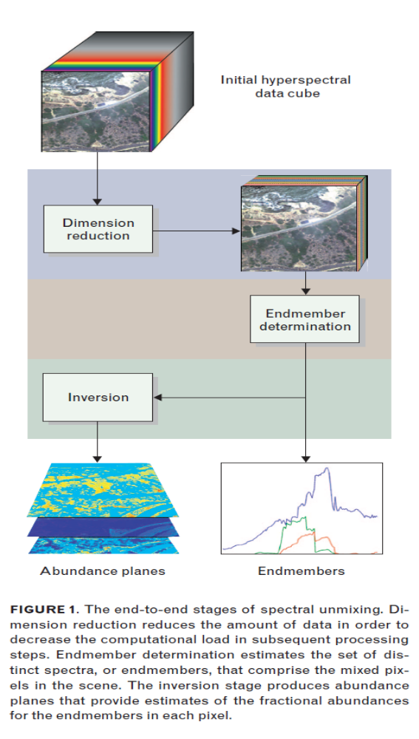

The top-down examination of the unmixing problem yields a set of three criteria that categorize
unmixing algorithms.
- interpretation of data, which indicates how an algorithm interprets mixed-pixel spectra;
(2) description of randomness, which indicates how an algorithm incorporates the randomness of the data
(3) optimization criterion, which indicates what objective function is being optimized by the algorithm.

Statistical-- If an algorithm processes a mixed pixel by using statistical measures (e.g., means or covariances), then the algorithm is statistical. Implicitly, statistical algorithms quantitatively introduce the aggregate behavior of a larger population of data into the processing of an individual pixel, and they do so having no knowledge of the probabilistic nature of
the data.
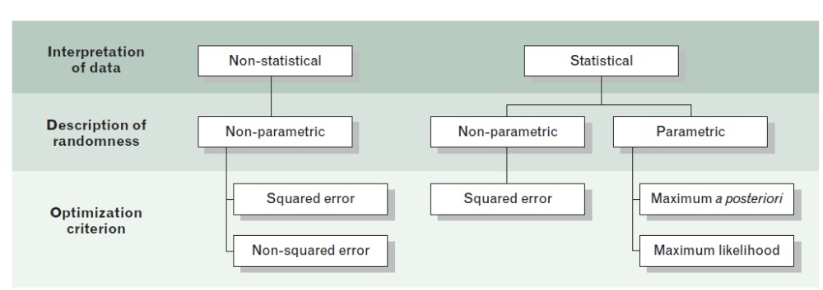
bottom-up approach identifies boundaries for delineating algorithms on the basis of the
operating characteristics that are unique to each stage. For example, the inclusion or omission of noise in signal models provides one axis of organization, whereas the added distinction between Gaussian and non- Gaussian noise yields further granularity. The features that distinguish algorithms are organized into three categories: output characteristics, input characteristics,
and noise modeling.

Mixing models:

Two mixing models.

(a) The linear mixing model assumes a well-defined proportional checkerboard mixture
of materials, with a single reflection of the illuminating solar radiation.

(b) Nonlinear mixing models assume a randomly distributed, homogeneous mixture of materials, with multiple reflections of the illuminating radiation. These models represent the underlying physics at the foundation of hyperspectral phenomenology. Unmixing algorithms use these models to recover endmembers and associated abundances from the mixed-pixel spectrum.
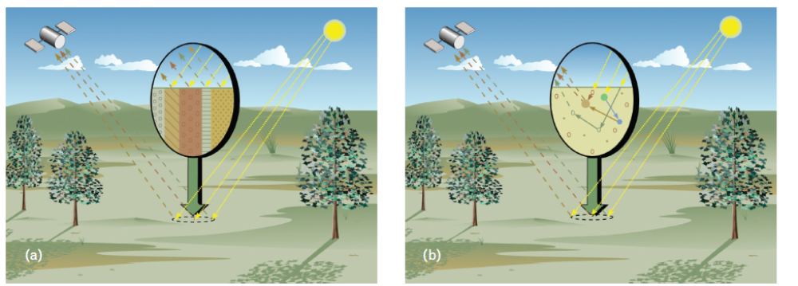

Linear Mixing Model(LMM):

The reflecting surface as a checkerboard mixture of endmembers, and the incident radiation bounces only once upon its surface. By this model, if the total surface area is divided proportionally according to the fractional abundances of the constituent substances, then the reflected radiation conveys with the same proportions the characteristics
of the associated materials.
The observed spectrum of x of any pixel can be represented as ,// homogenity mixtures
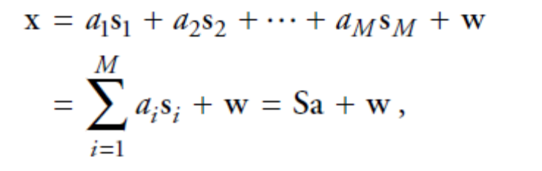
S_{i} – ith end member
A_{i –} ith abundance
M= # endmembers

Non Linear Mixing Model:

The arrangement of the constituent material substances is not as orderly because the substances comprising the medium are not organized proportionally on the surface. This intimate mixture of materials results when each component is randomly distributed in a homogeneous way. As a result, the incident radiation can experience reflections with multiple substances, and the aggregate spectrum of reflected radiation may no longer uphold the linear proportions (either in mass fraction or in volume) of the constituent substance spectrum. Because the LMM is inappropriate to describe this interaction, this scenario, which has many variations, is referred to
as nonlinear mixing.
//s1s2

Dimension-Reduction Taxonomy:
Set of algorithms that reduce the dimension of hyperspectral data

Goal: Arrive at a minimal representation of the signal in a lower-dimensional space that sufficiently retains the requisite information for successful unmixing in the lower dimension

(Do not reduce the dimension of data with the goal of reconstructing an approximation to the original signal)

- Statistical Non Parametric-
Non Parametric -do not presume any probability density function for the data
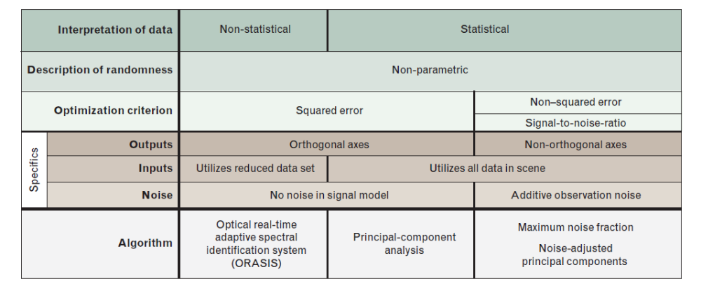
Eg, (a)PCA- identifies orthogonal axes for dimension reduction by performing an eigendecomposition of a covariance estimate of the data

Γx =Covariance matrix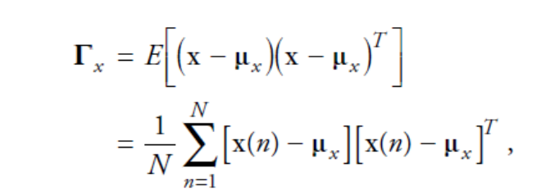
- Eigen value deconpostion of Γx= U Σ U ^{T}
- the effective dimensionality of the data can be estimated by counting the number of significantly non zero eigenvalues.
(b) Maximum Noise Fraction (MNF)
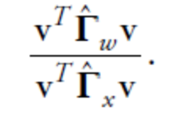
This approach, based on the LMM, requires estimating the covariance Γw for the additive noise in addition to the covariance Γx of the data.

Ratio of noise enrgy in v / received signal energy in v=

Non statistical and Non Parametric - Optical Real-Time Adaptive Spectral Identification System (ORASIS)

Endmember Determination Taxonomy:

The determination of S is comparable to the estimation of a nonorthogonal subset of basis vectors.

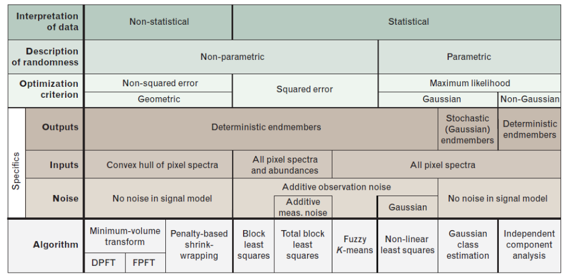

- Geometric Endmember Determination-- we can use the PCA results generated earlier to conclude that the number of significant eigenvalues is an approximate upper bound on the number of endmembers in a scene.

Taxonomy of inversion algorithms:
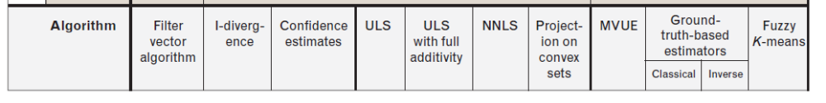

The objective of these algorithms is to determine the fractional presence of each endmember in the received pixel spectrum or, in terms of the LMM, find the vector a whose entries weight the columns of S to yield x.

Any meaningful estimate of a, however, must comply with constraints that make it physically realizable. With this in mind, any estimate of ‘a’ should obey the following constraints for non-negativity, purity, and full or partial additivity.

- Statistical Parametric Algo- least-squares analysis either by the squared-error-minimizing properties of the SVD and eigendecomposition, or the Euclidean geometry of Gaussian analysis.
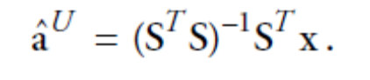
Optimization problem: minimize(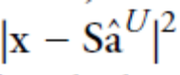)

What we have to minimize?
Non linear equations and definitions
Modelling of NL problem- like bilinear

